Weekly Construction Progress Report – Week 32
Harrow Bay Offshore Wind · 03 Aug – 09 Aug 2026
Elena Márquez · 10 August 2026 · HB-PM-RPT-2026-W32

1. Summary
1 monopile (HB-A11) was installed this week, bringing the total to 11 of 40. The foundation campaign is 2 piles behind the Rev 2 baseline (13 planned). Waiting on weather amounted to 19 hours.
Area | Status | Comment
Overall schedule | Amber | 11/40 monopiles vs. 13 planned
Foundations | Amber | TPs installed: 10
Offshore substation | Green | Jacket installed 27 Jun
Cables | Red | Export cable 2 delay – HB-RISK-017
HSE | Green | No incidents

2. Progress
Metric | This week | Cumulative | Plan (cum.) | Variance
Monopiles installed | 1 | 11 | 13 | -2
Transition pieces installed | 0 | 10 | – | –
Waiting on weather (h) | 19 | 239 | – | –
Persons on board (avg.) | 97 | – | – | –
Man-hours MV Sea Atlas | 8,163 | 144,364 | – | –
Lost time injuries | 0 | 0 | 0 | 0
Recordable injuries | 0 | 1 | – | –
Near misses reported | 0 | 3 | – | –
HSE observation cards | 26 | – | – | –

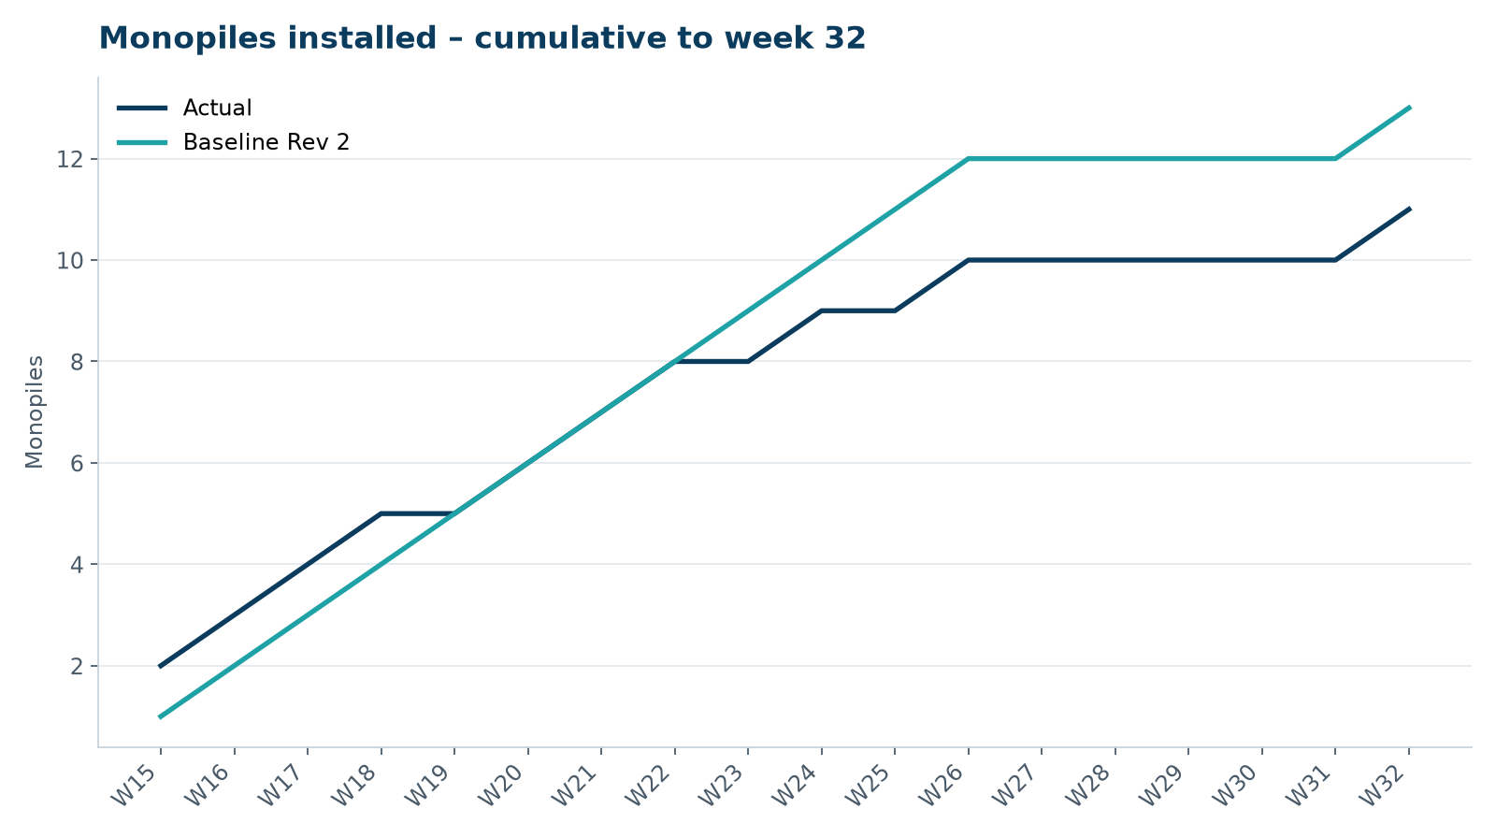
Figure 1 – Monopile installation progress, W15 to W32

3. Key activities this week
- HB-A11 installed on 6 August – piling resumed after the summer restriction.
- Peak noise 158.6 dB SEL at 750 m.
- 19 hours waiting on weather.

4. Health and safety
No lost time injuries. 26 observation cards submitted; top theme: line-of-fire during lifts.

5. Environment
- HB-A11: peak 158.6 dB SEL at 750 m (compliant); pre-piling search clear, soft start on time.

6. Issues and risks
- HB-RISK-017 export cable 2 delay – re-manufacture of 9 km section confirmed; delivery forecast 12 March 2027.
- HB-RISK-001 weather: 19 h downtime this week.

7. Look-ahead next week
Install HB-A12; OSS topside lift window opens 17 August.
Prepared by Project Controls (Gareth Lewis); approved by Elena Márquez. Distribution: project team, Steering Committee, Halden Turbine Systems, Lenders' Technical Adviser.

